**Task Management System :**

**Objective:**

To develop a console-based task management system that allows users to manage tasks, including adding, updating, and deleting tasks, setting deadlines, and marking tasks as complete. This system uses collections, file handling, JDBC, and database (SQL) for data storage and retrieval, with Git for version control.

**Identification Needed:**

To provide a Task management application that allows users to manage their tasks and deadlines easily.

**Platform Specification:**

**Hardware:**

INTEL CORE I3,I5,I7 OR MAC,MINIMUM 4GB RAM

**SOFTWARE:**

JAVA ,SQL ,JDBC,JIRA

**Functional Requirements:**

**User Account Management:**

* Create User Accounts: Add users with roles (Admin or User) and assign account details.
* Update User Information: Modify user details like email, first name, and last name.
* View User Details: Display user information, including role and registration date.

**Project Management:**

* Create and Assign Projects: Create projects and assign to specific users.
* Update Project Information: Edit project details such as description, start date, and end date.
* View Project Details: Display project information along with associated tasks.

**Task Management:**

* Create, Update, and Delete Tasks: Allow users to add, modify, or remove tasks.
* Set Deadlines and Priority: Set task deadlines and priority levels (Low, Medium, High).
* Mark Tasks as Complete: Update task status to "Complete."

**USE CASE DIAGRAM:**

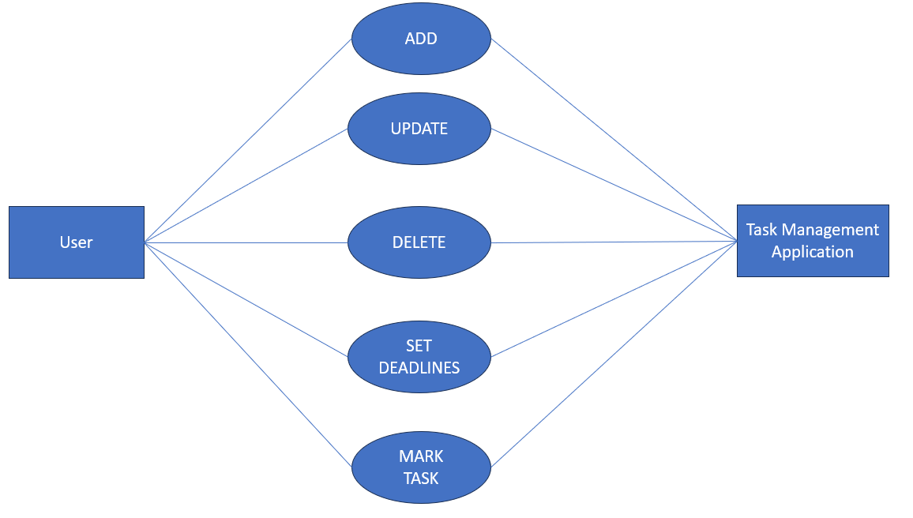

**SCHEMA DESIGN:**

**USERS:** Stores information about each user in the system

Columns:

* user_id INT UNIQUE (PK)
* username VARCHAR(100)
* email VARCHAR(100)
* password VARCHAR(255)
* first_name VARCHAR(100)
* last_name VARCHAR(100)
* role VARCHAR(50) (e.g., "Admin", "User")
* created_at DATETIME

**PROJECTS:** Stores project details, associated with a specific user (project owner)

Columns:

* project_id INT UNIQUE (PK)
* user_id INT (FK) – References user_id in the USERS table
* project_name VARCHAR(255)
* description TEXT
* start_date DATETIME
* end_date DATETIME

**TASKS:** Stores information about individual tasks, associated with a project and user

Columns:

* task_id INT UNIQUE (PK)
* user_id INT (FK) – References user_id in the USERS table
* project_id INT (FK) – References project_id in the PROJECTS table (optional)
* task_name VARCHAR(255)
* description TEXT
* status VARCHAR(50) (e.g., "Pending", "In Progress", "Completed")
* deadline DATETIME
* priority VARCHAR(20) (e.g., "Low", "Medium", "High")
* created_at DATETIME
* updated_at DATETIME

**SCHEMA DESIGN:**

